**Section A: Data Warehouse Modelling -> Data import**

**Step 0 Obtaining and unzipping data**

I’ve started by downloading the data file from the [assignment page](https://brightspace.tudublin.ie/d2l/common/viewFile.d2lfile/Database/MzQyNzI0Ng/data.zip?ou=231092), moving it to my assignment folder and unzipping it:

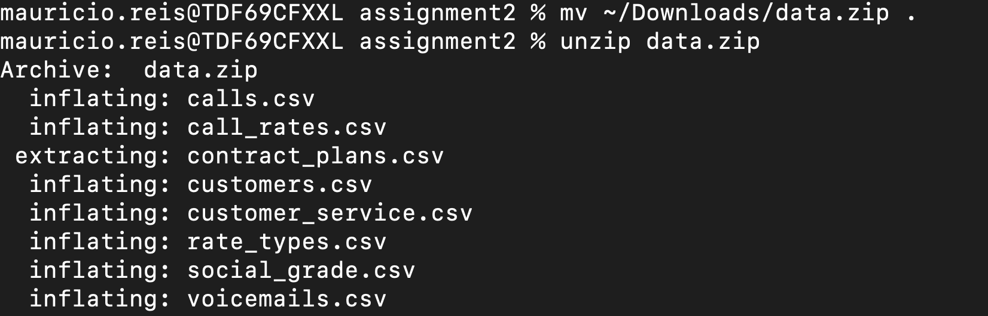

*Image 0: Moving and Unzipping assignment data*

**Step 1: Create New Database Connection**

I’ve created a new database connection on SQL Developer with a pre-existing Oracle Database on my local machine.

*Image 1: Creating Database Connection on Oracle SQL Developer*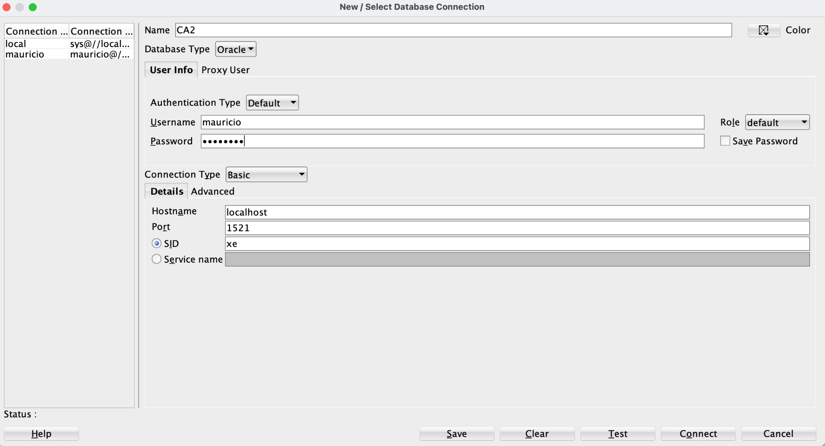

**Step 2: Deciding how to import the data**

I’ve decided that it was easier to just import everything right away and understand the data better with queries once it was imported into the database. The reason for that is on Image 2, there you could see that I was not dealing with big data here but just with a group of very small files (the largest csv file on this group has just 14MB).

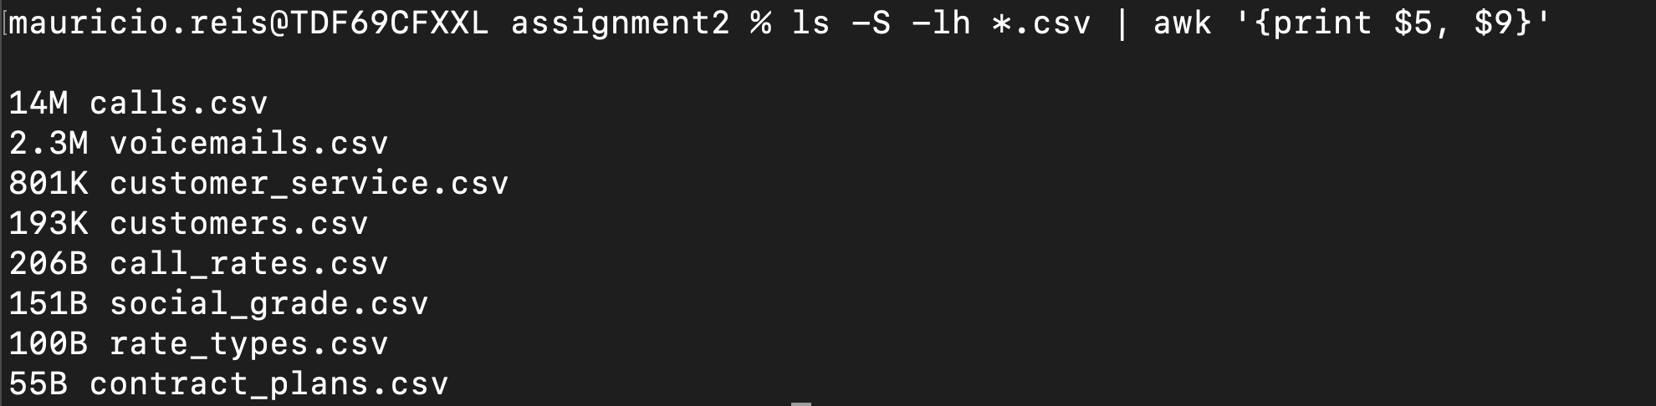

*Image 2: .csv Data Files Size*

**Step 3: Importing data into an Oracle Database using SQL Developer**

**3a. Import Call Rates**

In all the table imports on SQL Developer, I did a few things in common with other imports:

* Right Clicked on “Tables” on my database connection and chose Import Data.
* Chose a file from the folder where I unzipped the CSVs for this work.
* Left the defaults for csv file on step 1 of 5 import page as you can see on Image 3 (header on, delimiter “,”, encoding UTF8, string enclosure “”, etc)

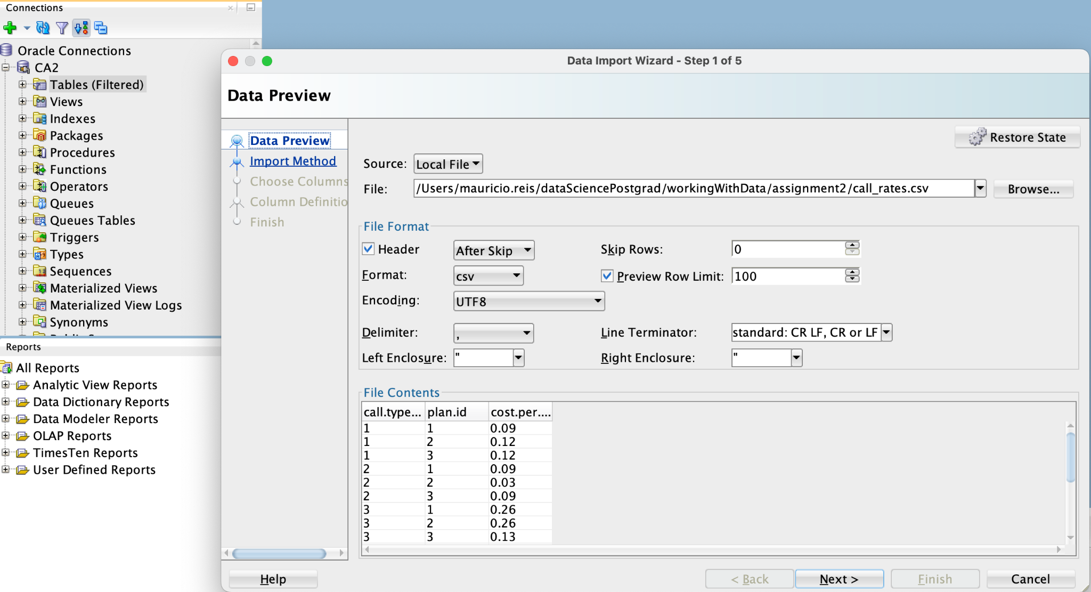

*Image 3: Import call_rates with defaults for csv*

* Created the Table name with the same name as the csv file and imported all the rows as seen on Step 2 of Data import on Image 4. I also imported all columns from each csv as shown on Image 5.

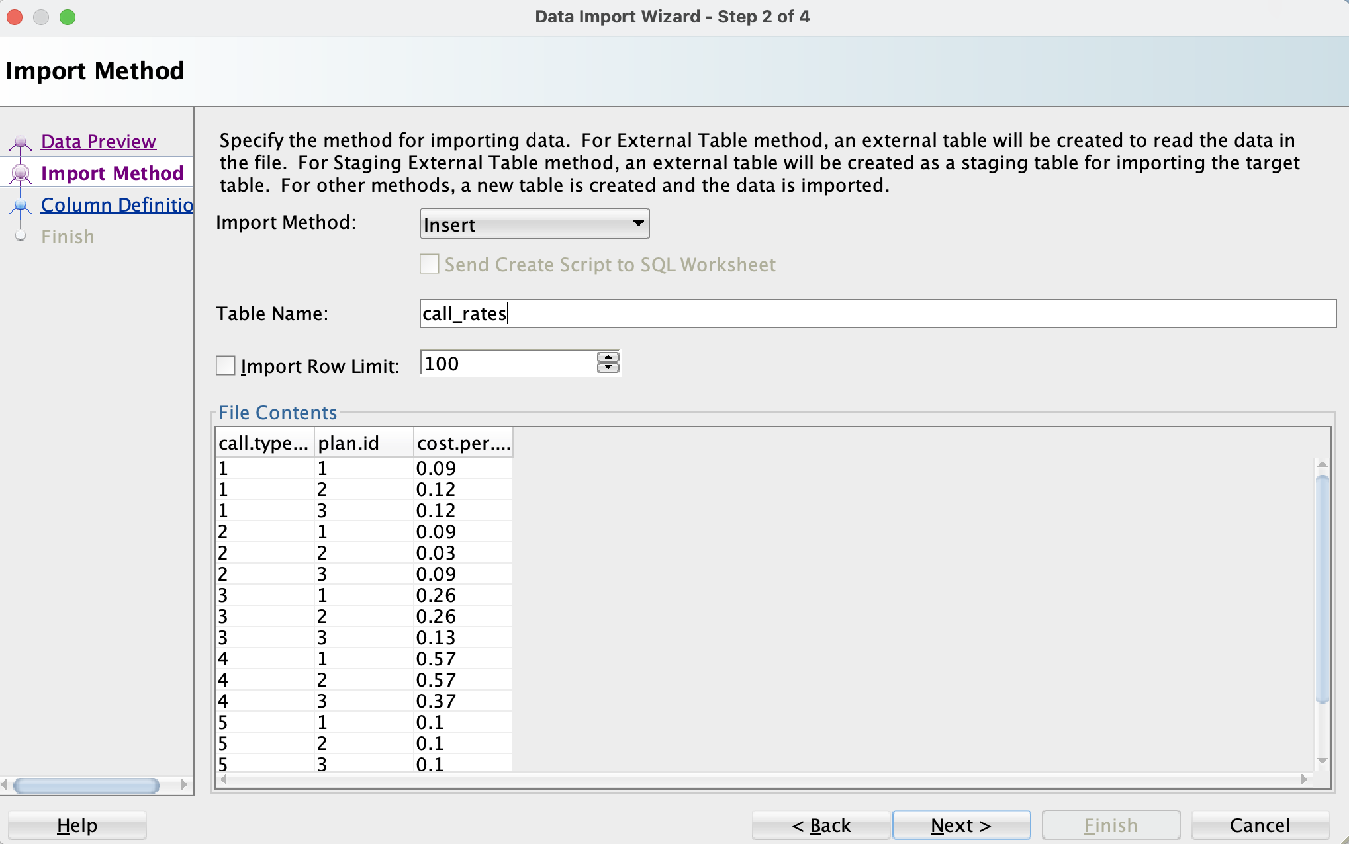*Image 4: Defining call_rates Table name for import from .csv*

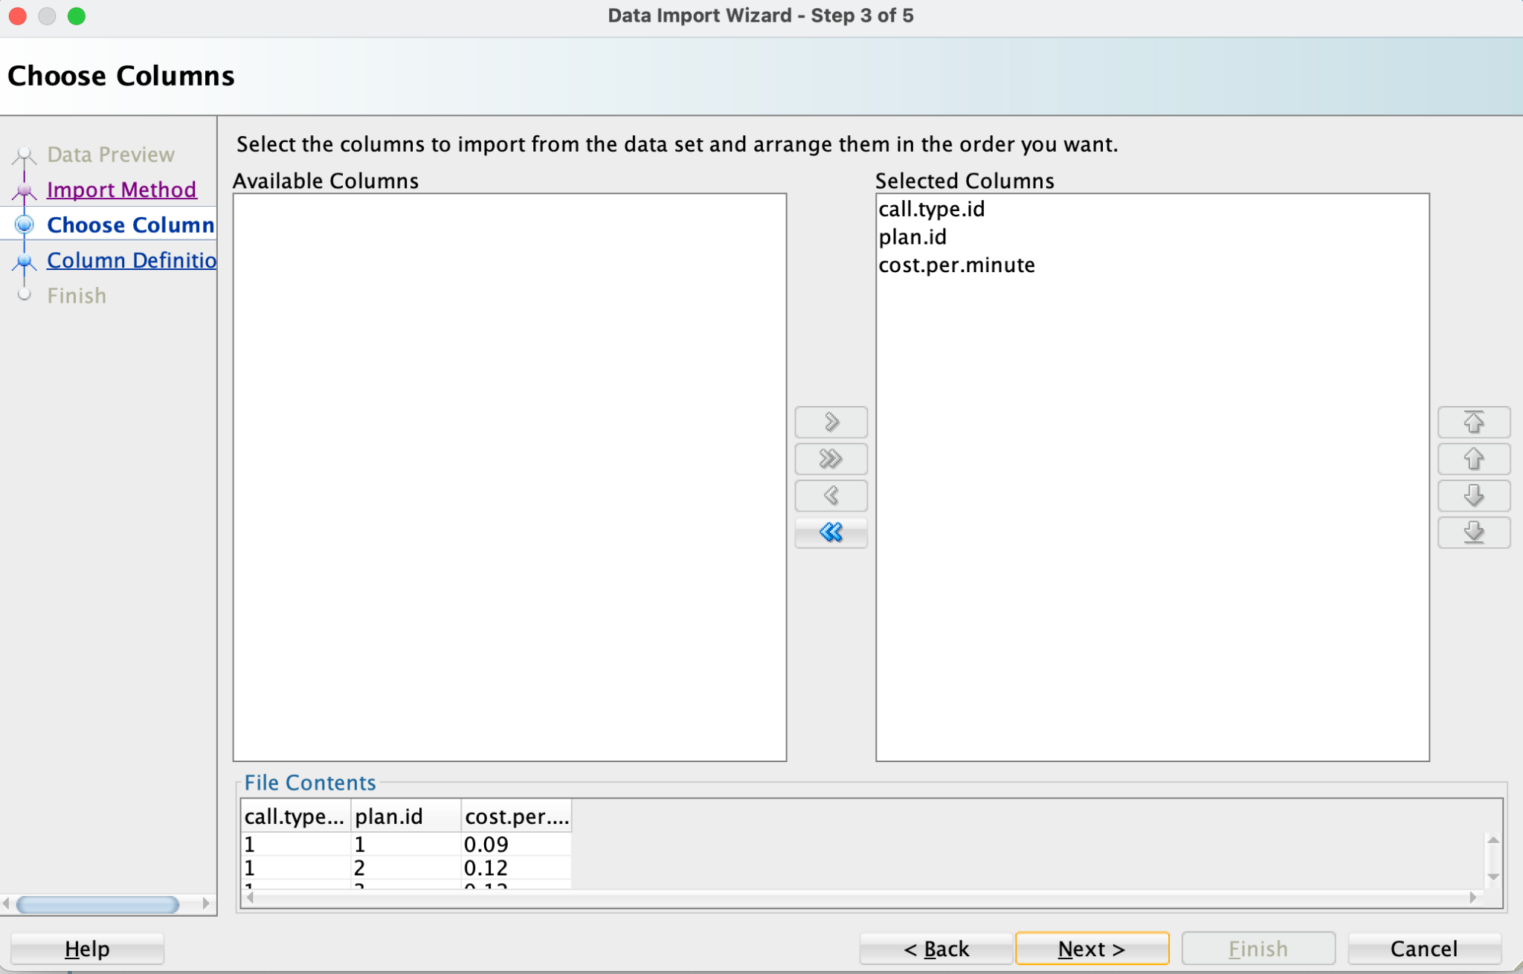*Image 5: Importing all call_rates columns from the .csv*

On the column names, I always replaced any “.” chars, which are invalid on Oracle column names, by “_” chars as shown on Image 6. I also opted in general to keep the default data types size/precision suggested by SQL Developer for each column when they could be a VARCHAR or a Numeric value. I just changed date values as the SQL Developer got the date formats all wrong by default:*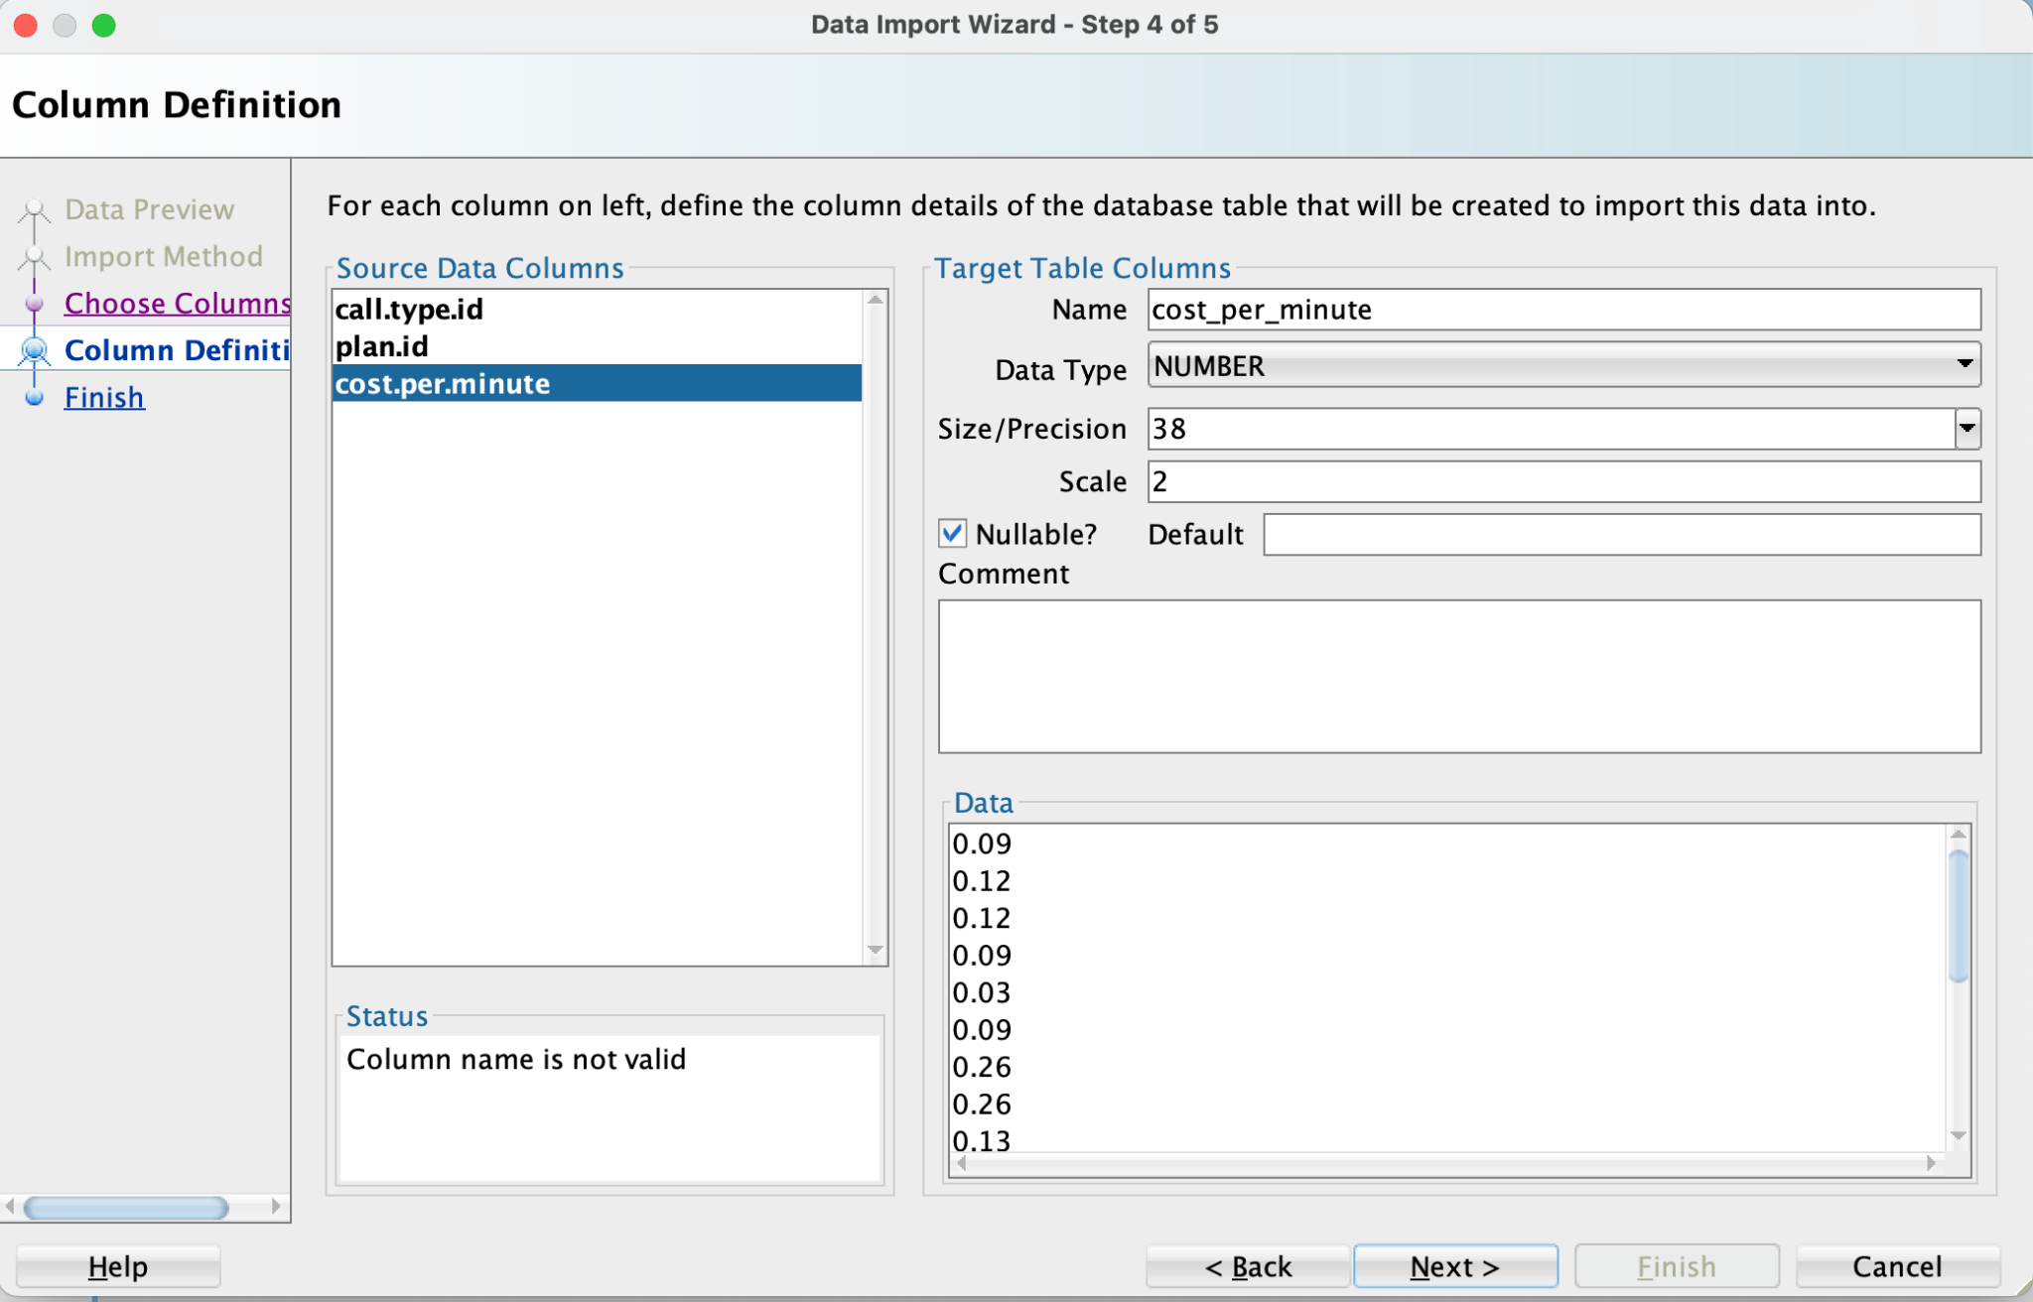Image 6: Defining call_rates table columns*

* I’ve captured an image of the final Data Import Page since it gives a summary showing, among other things, the original columns names and what I’ve transformed them into, the column types and the import configurations. You can see the Call Rates Import final page on Image 7.

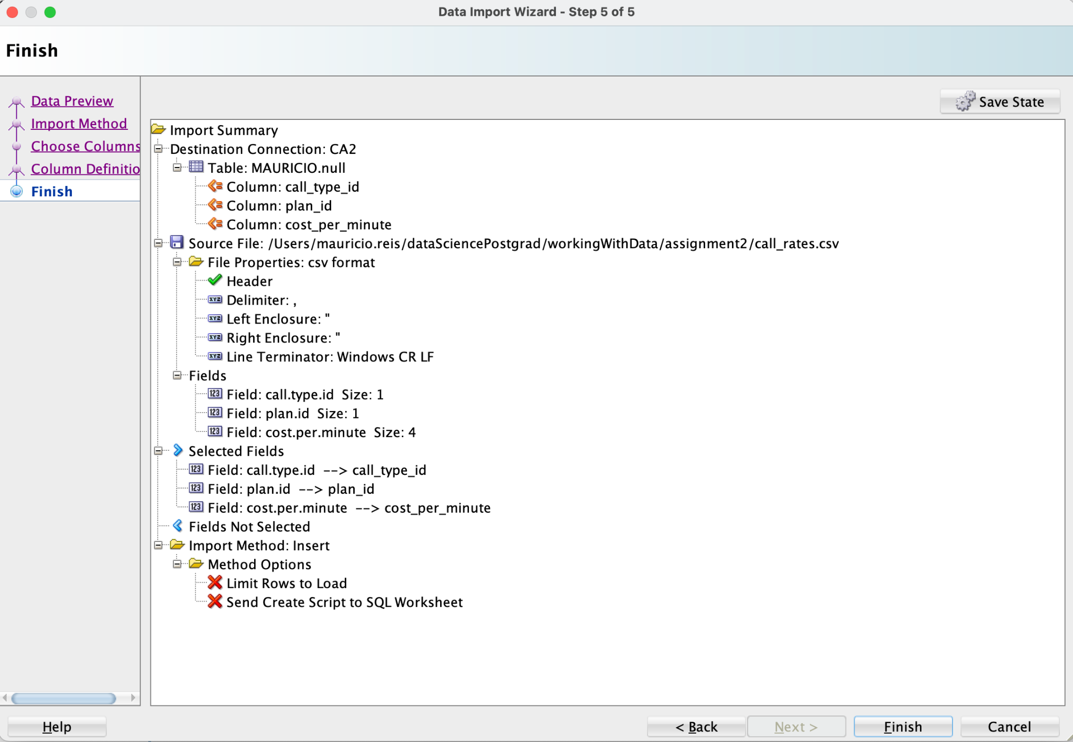*Image 7: call_rates Import Summary*

**3b. Import Calls**

On importing calls, Images 8,9 and 10, I’ve transformed call_time into date with the format DD-MM-YY HH24:MI. I also replaced all the “.” in column names by “_”. I’ve tried to transform the flags is_international and is_roaming into boolean values but I couldn’t find a suitable type in this SQL Developer interface.

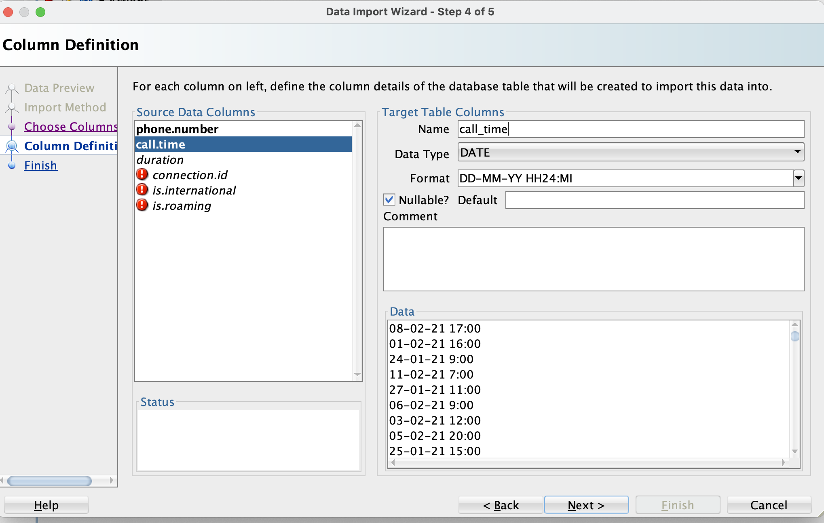*Image 8: Defining date format in Calls Column Definition 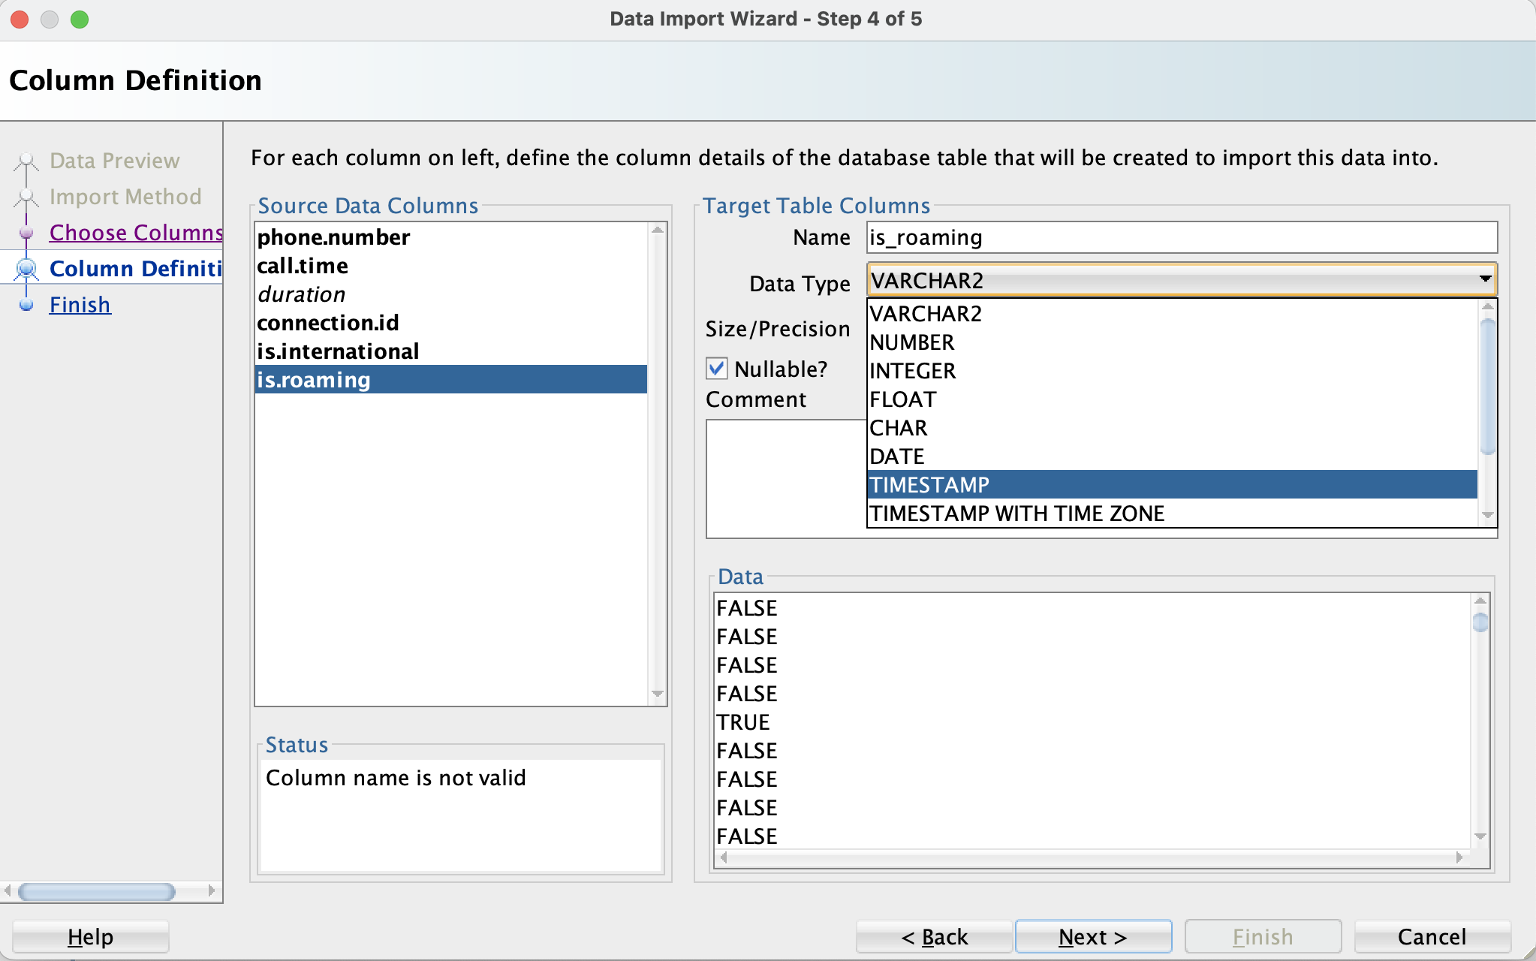Image 9: Trying to find a boolean type for table Calls flags. 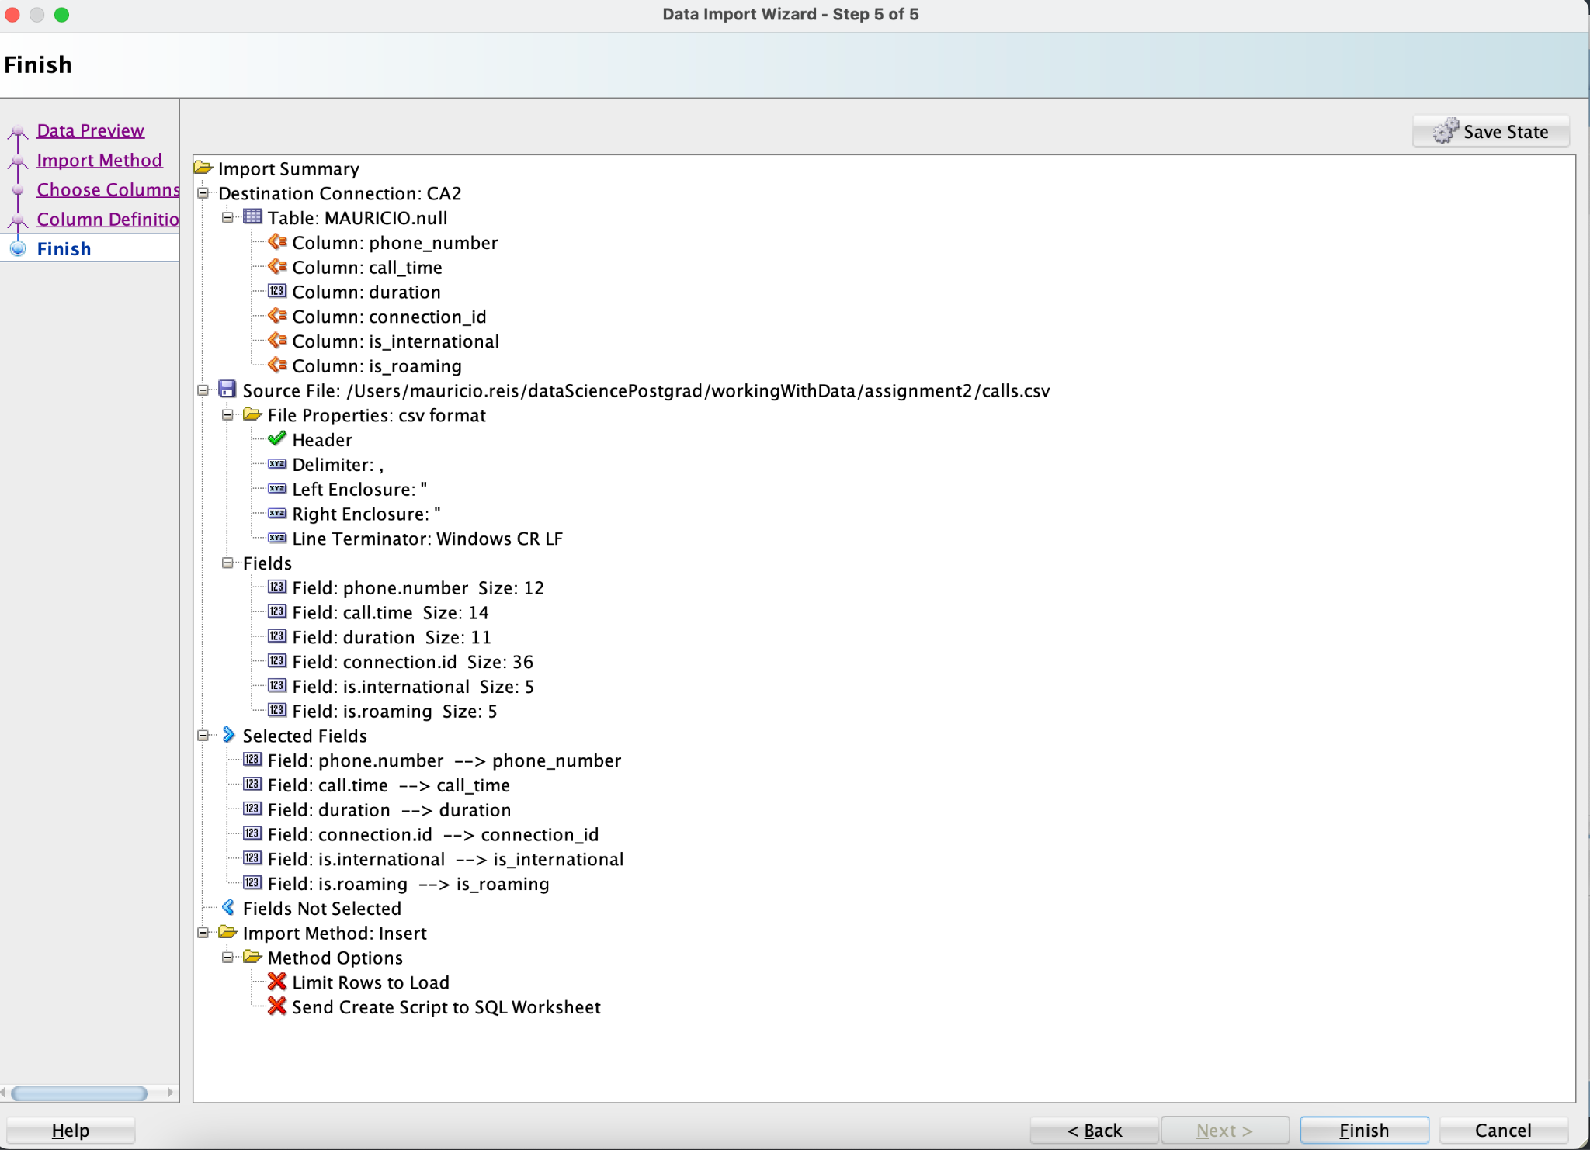Image 10: Calls table Data Import Summary*

**3c. Import Contract Plans**

Contract Plans was just imported with all its defaults as seen on the Summary on Image 11

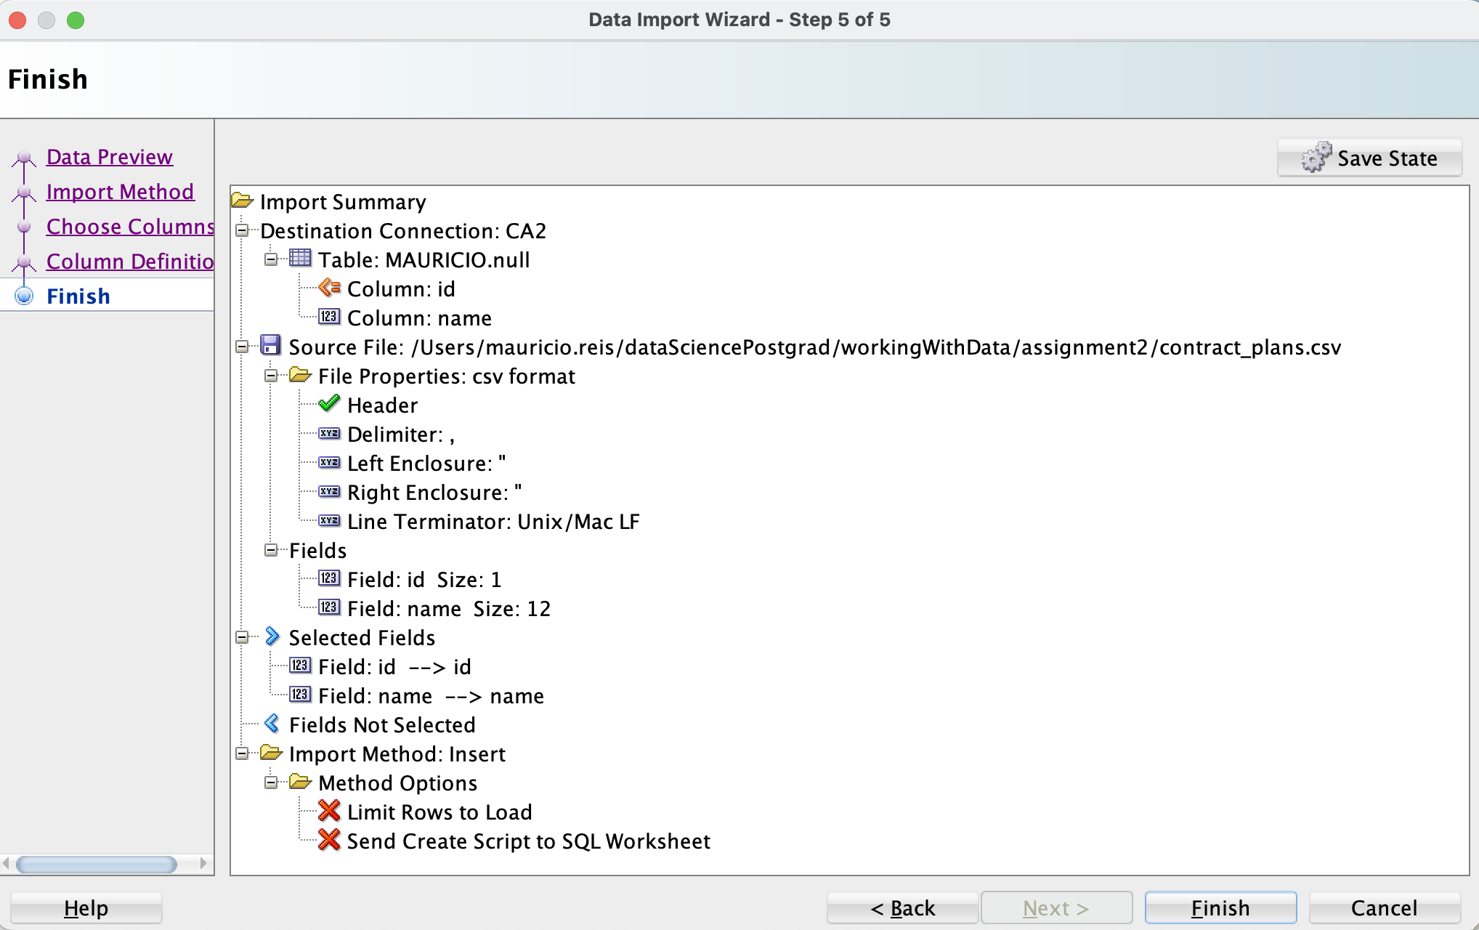*Image 11: contract_plans table Data Import summary*

**3d. Import Customer Service**

I’ve converted call time into date and used the format DD-MM-YY HH24:MI. Replaced “.” by “_” on column names and left all the rest default as seen on images 12 and 13

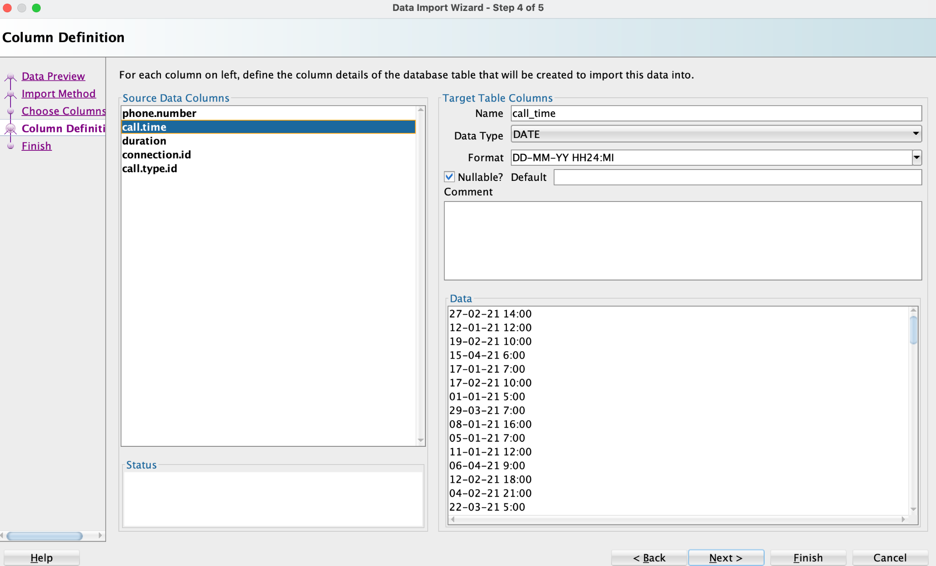*Image12: customer_service column definition*

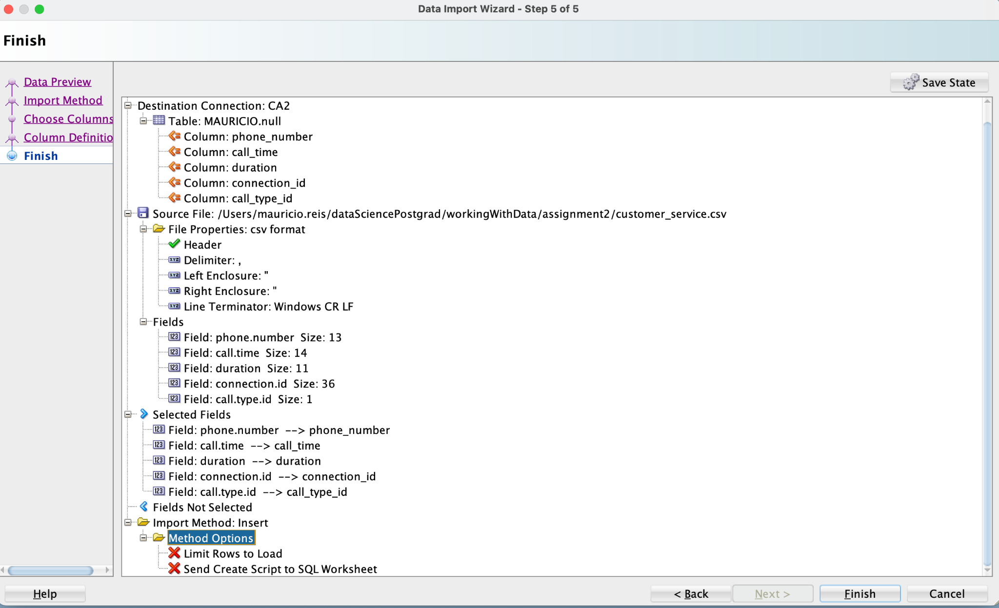*Image 13: customer_service table Data Import summary*

**3e. Import Customers**

SQLDeveloper guessed customer’s dob, contract start and contract end date were dates but got their format wrong. I’ve correct the format to DD-MM-YY as seen on Image 14 and replaced the “.” chars. The rest was left as default as shown on Image 15.

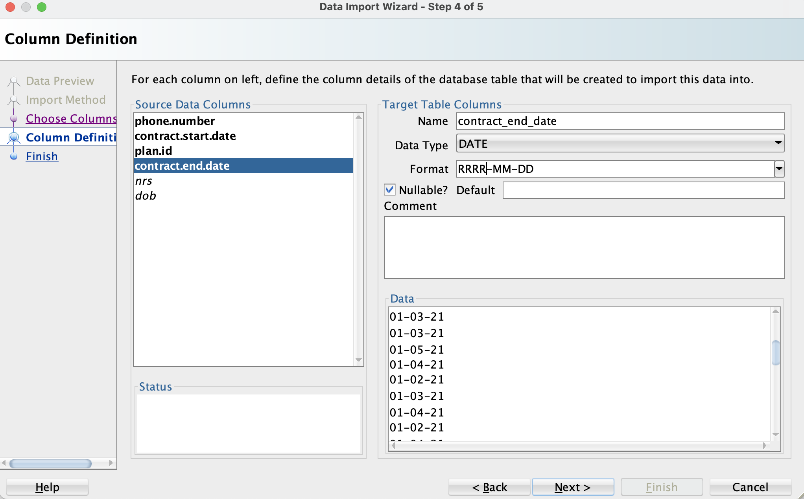*Image 14: customers table Column Definition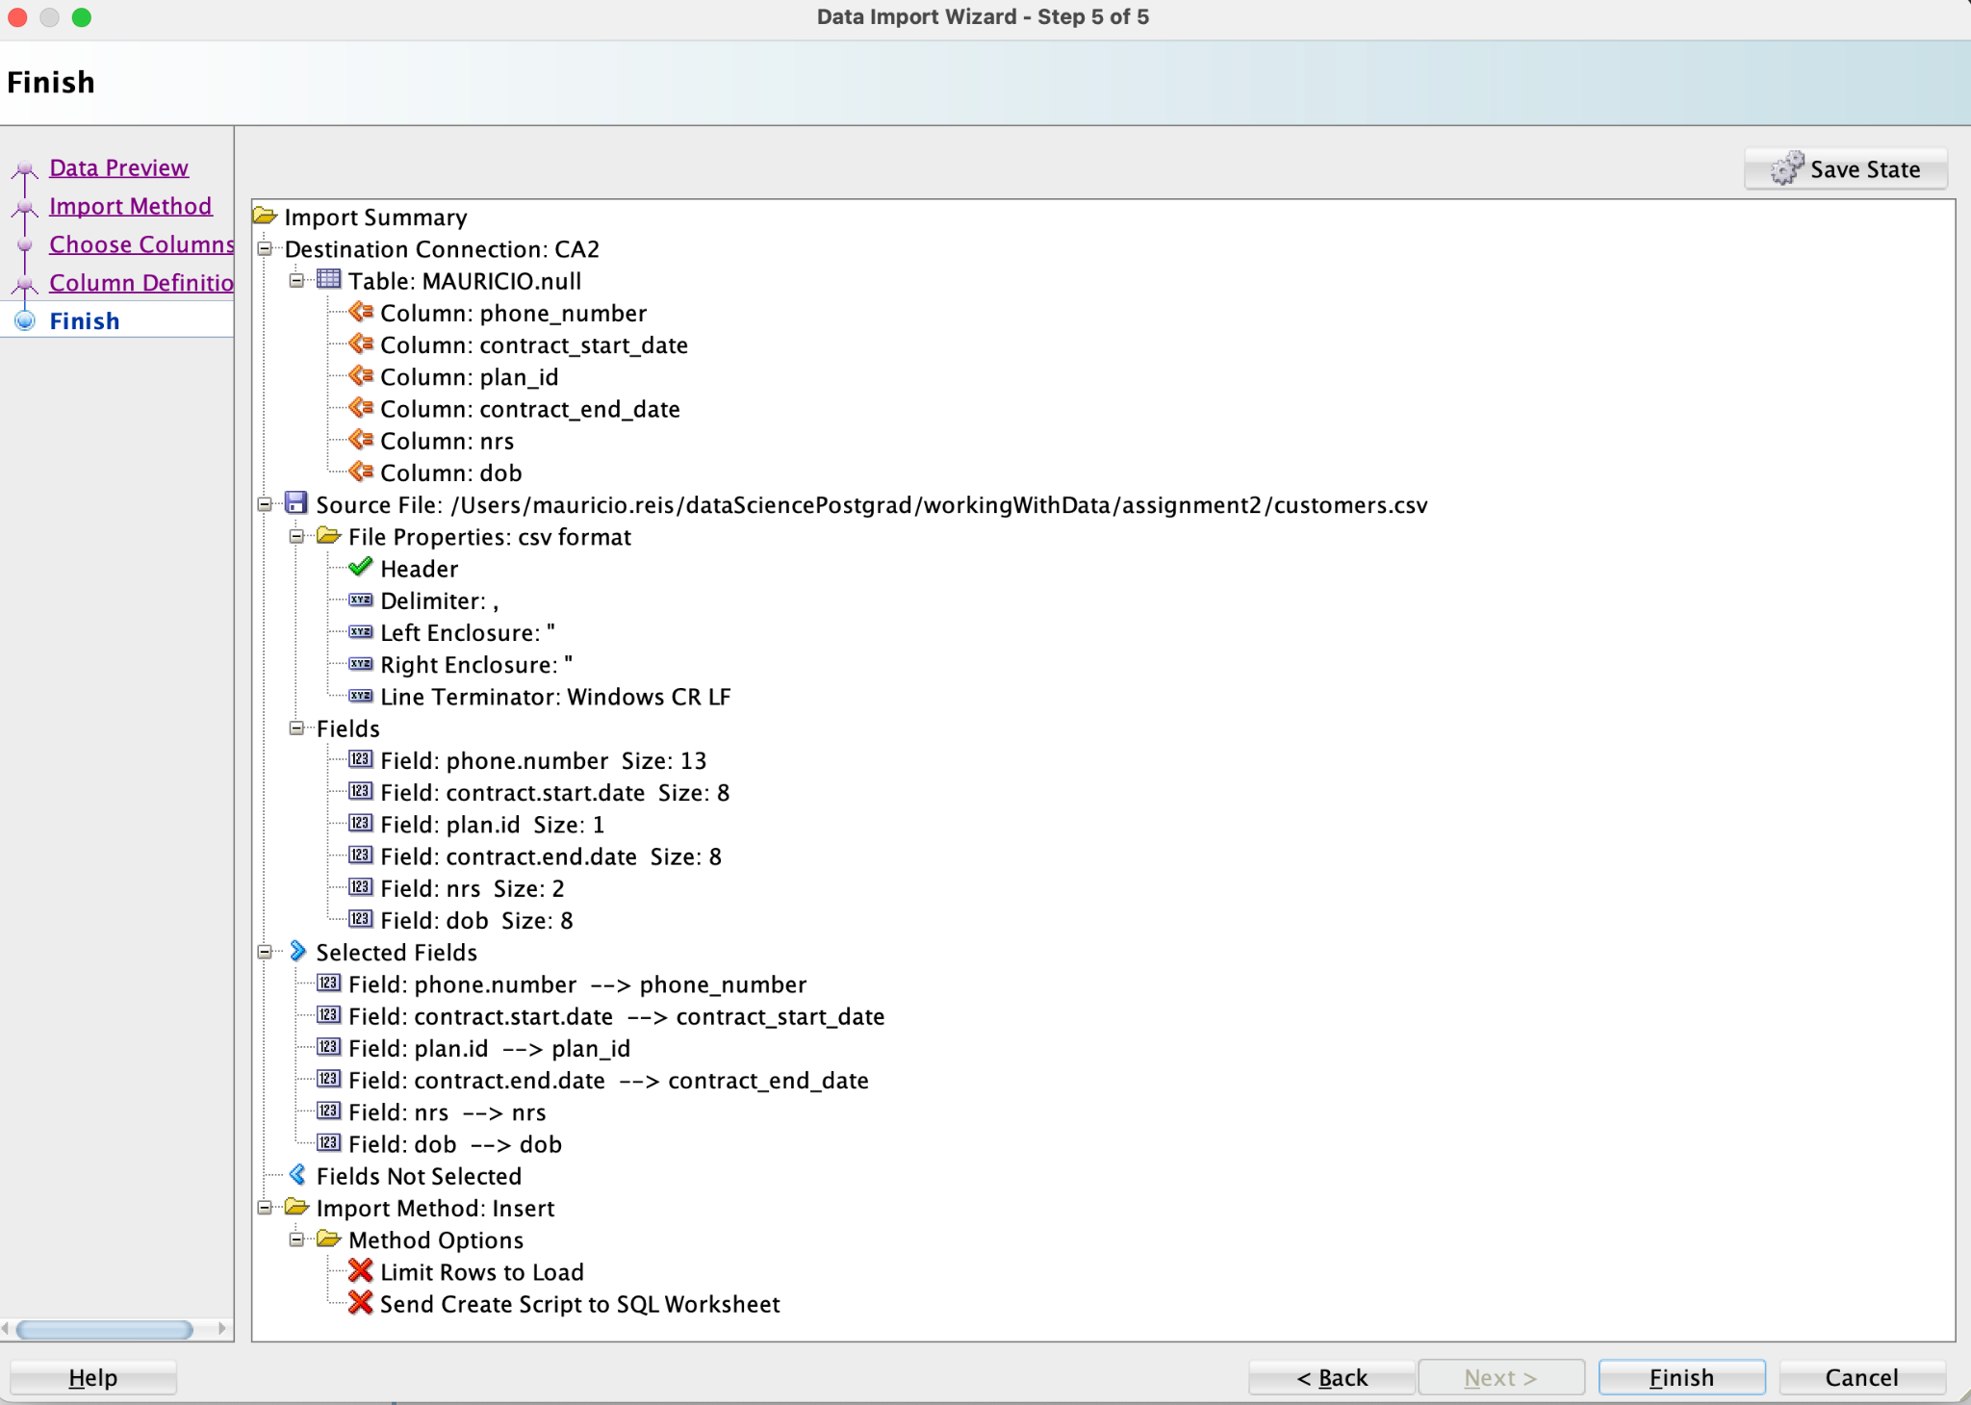Image 15: customers table Data Import summary*

**3f. Import Rate Types**

Rate Types was imported with all the Defaults as seen on image 16.

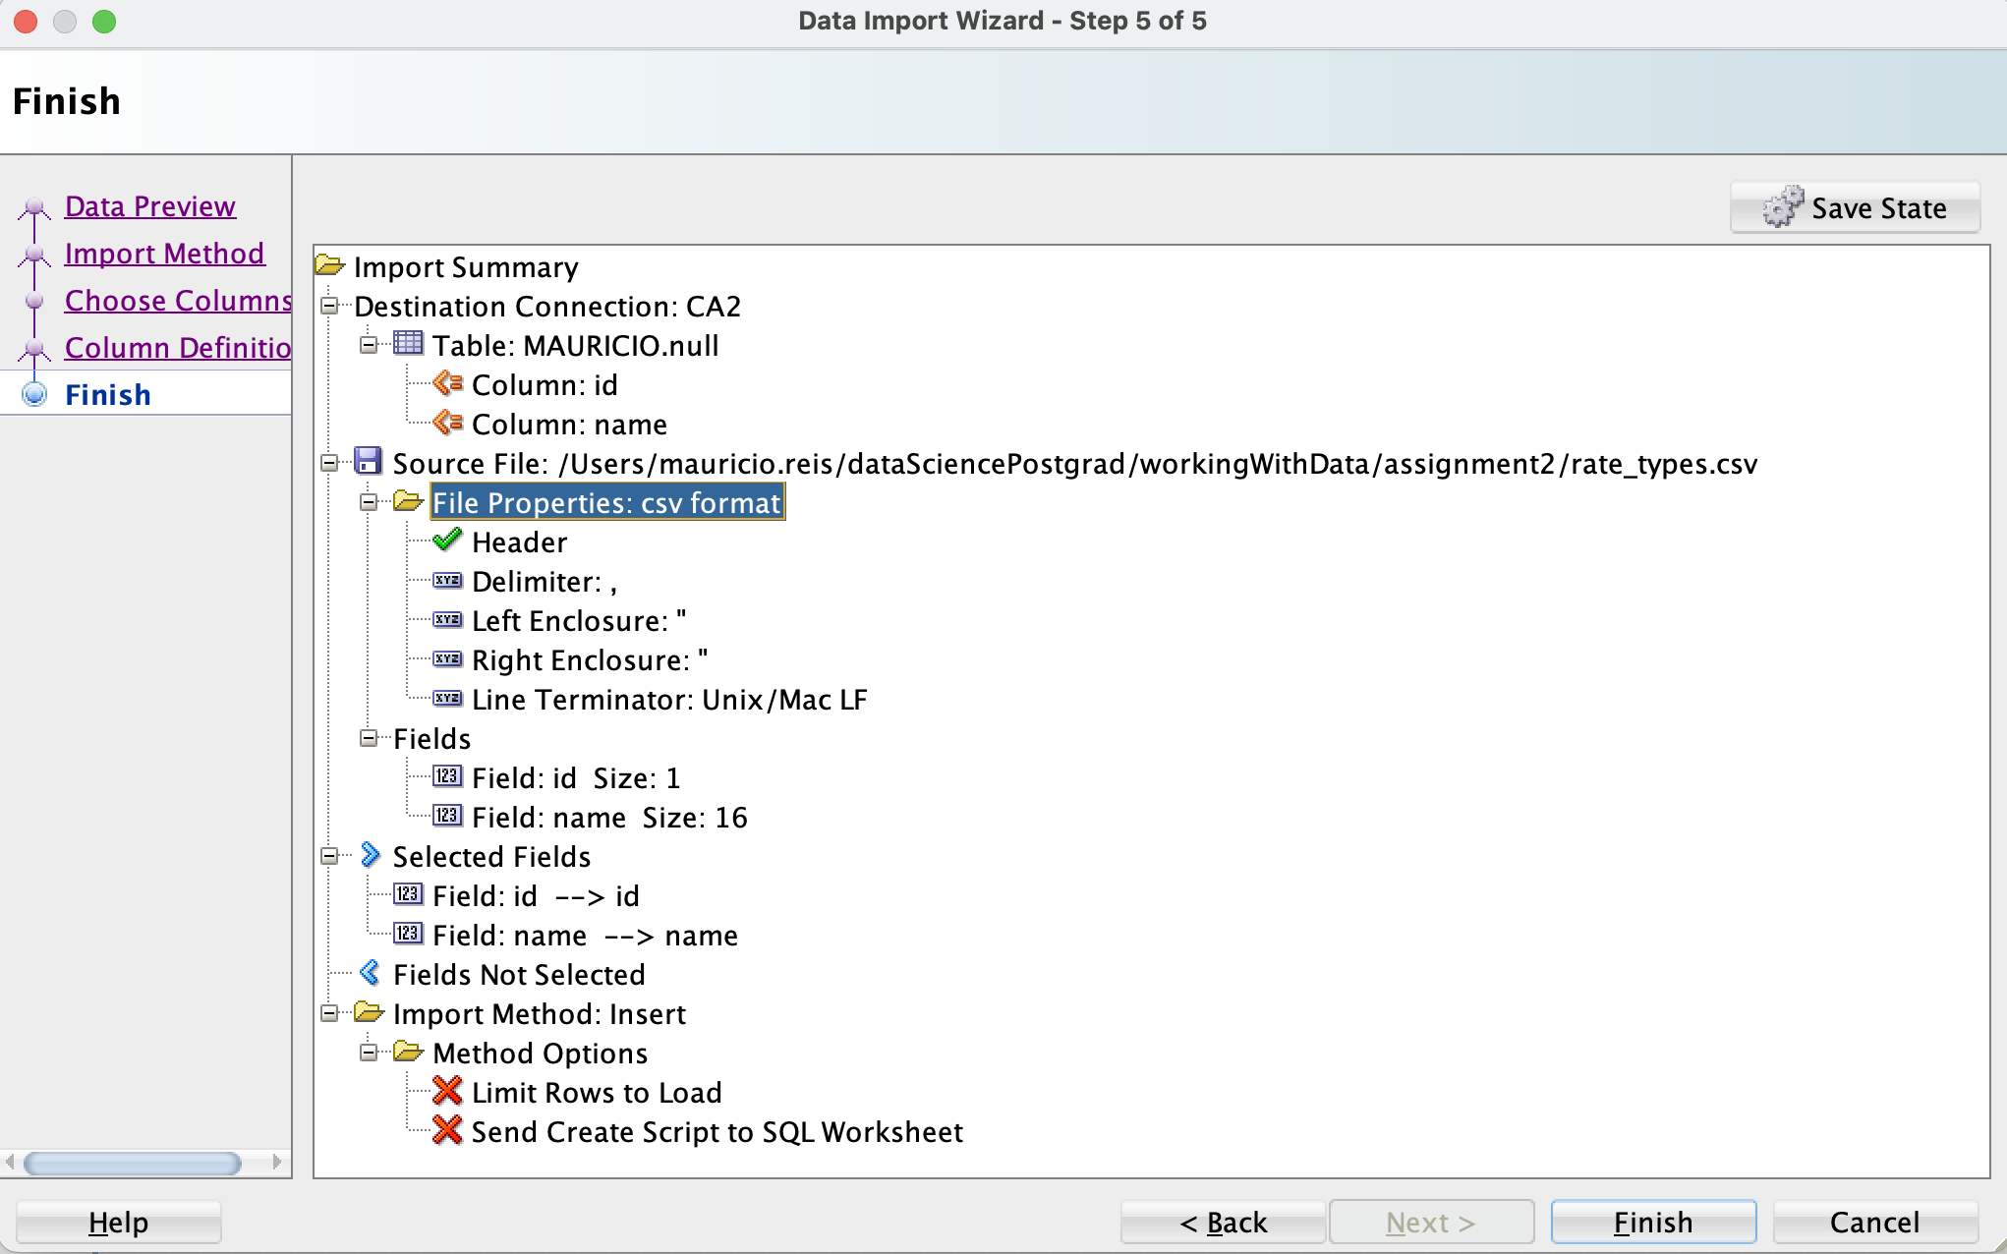*Image 16: rate_types table Data Import summary*

**3g. Import Social Grade**

On Social Grade Column Definition, Image 17, I had to remove the spaces in the end of the Grade column and also replace the empty space by a “_” in the “Social Class” column name. The rest was left as default as seen on Image 18

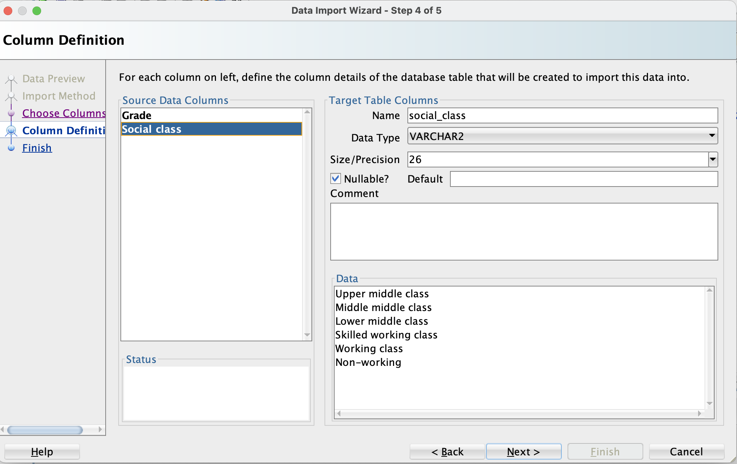*Image 17: Social Grade Column Definition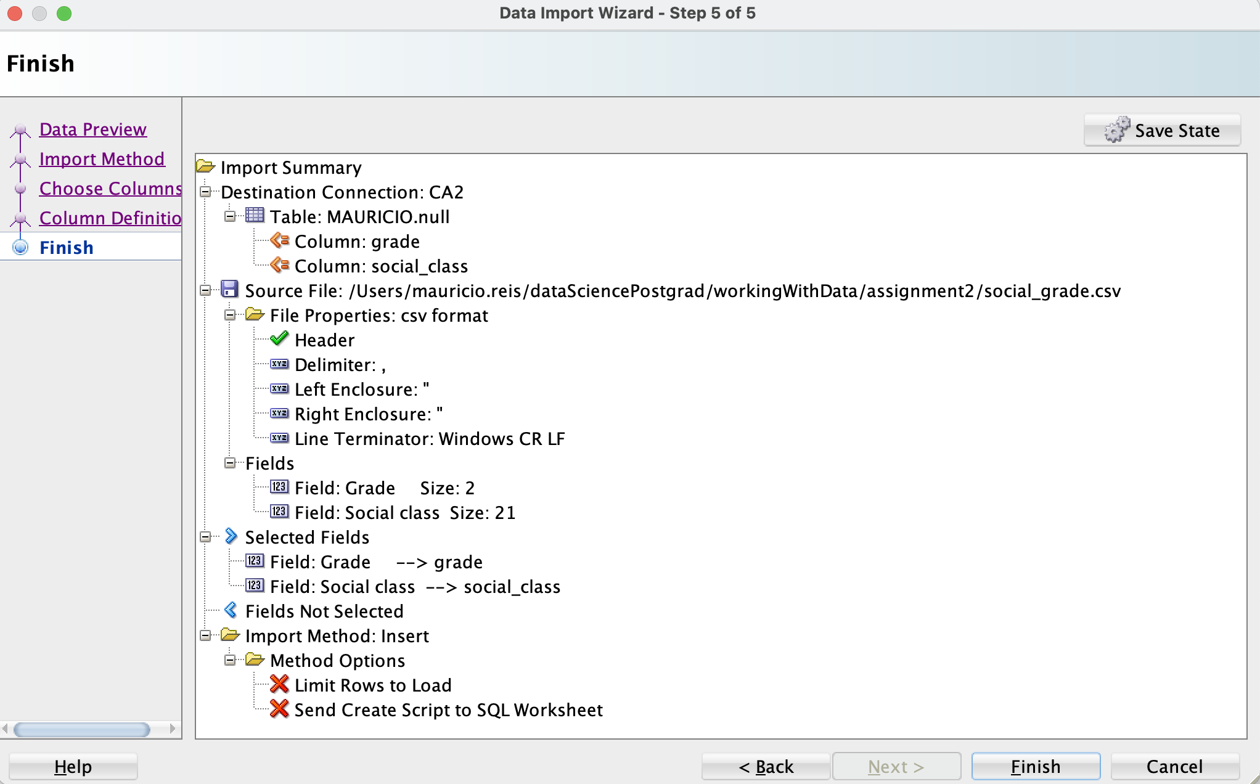Image 18: social_grade table Data Import summary*

**3h. Import Voicemails**

On Voicemails Column Definition, Image 19, I’ve changed call_time data type to be a date in the format DD-MM-YY HH24:MI and replaced “.” by “_” in column names. The rest was left as default as seen on Image 20

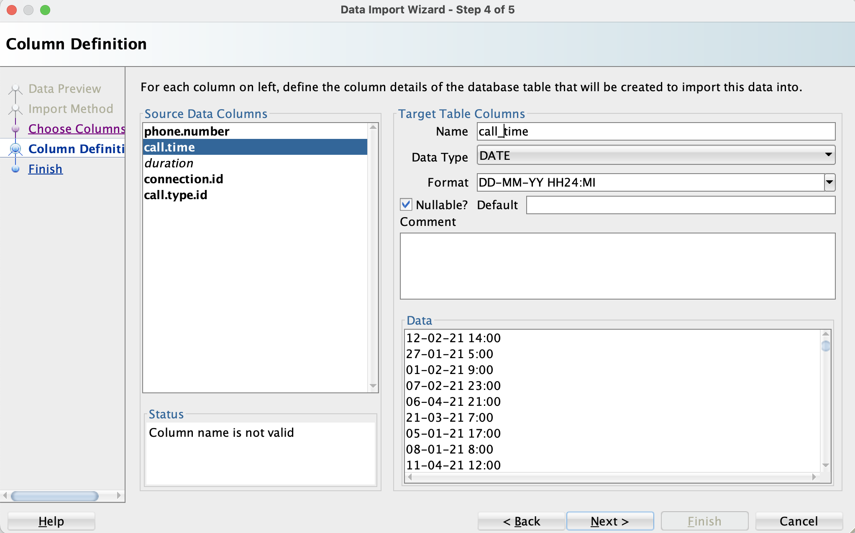*Image 19: Voicemails Column Definition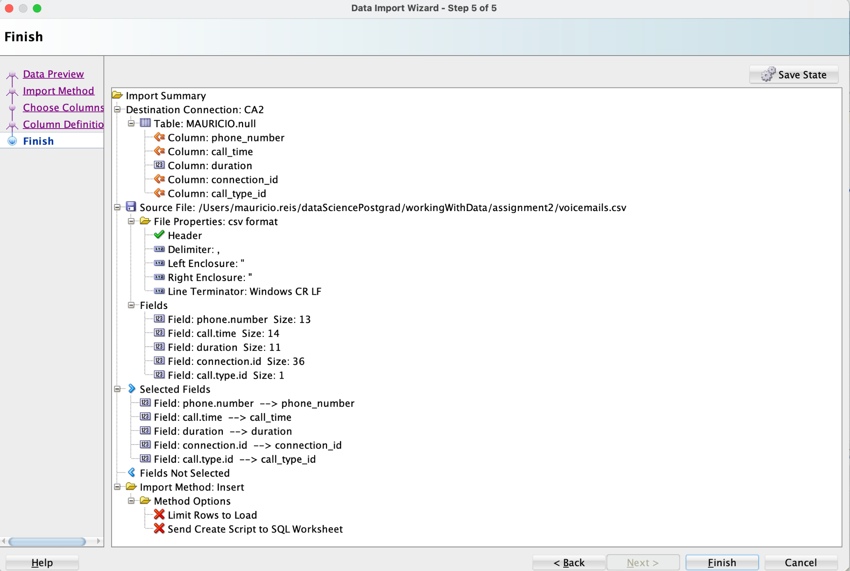Image 20: voicemails table Data Import summary*